Block-Level Code Coverage Tool
for Embedded C/C++ Source Files
A Static-Instrumentation Approach to Execution Tracing and Visual Coverage Reporting

Table of Contents

Table of Contents 1
1. Abstract 1
2. Problem Statement 1
2.1 Objectives 1
3. System Architecture 1
3.1 Component Overview 1
3.2 Processing Pipeline 1
3.3 Flag Naming Convention 1
4. Implementation 1
4.1 Block-Boundary Detection 1
4.2 Same-Line Brace Normalisation 1
4.3 Runtime Logging Macro 1
4.4 Visual Coverage Resolution 1
5. Results 1
5.1 Flag Injection Summary 1
5.2 Performance Improvement 1
5.3 Coverage Report Output 1
6. Conclusion 1

1. Abstract
Code coverage analysis is a critical step in validating embedded software, where untested branches in safety- or reliability-critical control logic can silently mask defects. This project presents a lightweight, dependency-free code coverage instrumentation tool designed specifically for embedded C/C++ projects composed of a main file and multiple dependency source files.
Rather than relying on heavyweight third-party coverage frameworks (such as gcov or LCOV, which require specific compiler flags and toolchain integration that are not always available in constrained embedded build environments), this tool performs source-level static instrumentation. It parses C/C++ source files using a custom tokeniser and recursive-descent analyser, identifies every execution-block boundary — including if/else chains, loops, switch statements, and function bodies — and injects lightweight logging macros at each boundary.
During execution, each instrumented point records a hit in an in-memory buffer, which is periodically flushed to a coverage log in large batches to minimise I/O overhead — a critical optimisation discovered after initial testing revealed a 100x+ slowdown from naive per-hit file writes. After program execution, a Python-based HTML report generator parses the log and the original (uninstrumented) source files to produce a colour-coded, file-by-file visual report: green for executed blocks, red for blocks that were never reached, with execution counts displayed inline.
The tool further supports recursive project folder structures, full project mirroring, and a desktop GUI for non-command-line users, making it accessible across a range of embedded development workflows.

2. Problem Statement
Embedded C/C++ projects are frequently organised as a primary application file (commonly main.c) that depends on a number of supporting driver or utility source files (e.g. sensor.c, actuator.c). Verifying that test execution genuinely exercises every conditional branch, loop iteration, and function across this multi-file structure is essential for catching unreachable code, dead branches, and incomplete test scenarios — yet standard coverage tooling is not always practical in embedded contexts for several reasons:
- Toolchain constraints: Many embedded compilers and cross-compilation environments do not support gcov-style coverage instrumentation flags, or support them inconsistently across targets.
- Opaque execution environments: Code is sometimes transferred to and executed within separate build/test environments where direct profiling instrumentation cannot be configured.
- Lack of visual feedback: Even where raw coverage data can be obtained, translating a flat list of hit counts into an intuitive, file-by-file visual understanding of which branches were and were not exercised is non-trivial.
- Multi-file dependency tracking: A function defined in one file may be called from another; verifying coverage holistically across this dependency graph requires consistent, collision-free instrumentation naming.
This project addresses these constraints by instrumenting source code directly — independent of compiler or build-system support — and by producing both raw log data and a clear, browsable visual report that maps execution results directly back onto the original source code.

2.1 Objectives
- Automatically detect every execution-block boundary (if/else, loops, switch, functions) in arbitrary C/C++ source files without requiring manual annotation.
- Inject lightweight, non-intrusive logging calls that do not alter program logic or control flow.
- Support multi-file embedded projects with arbitrary subfolder structures, preserving the original project layout.
- Minimise runtime performance overhead, even for loops executing millions of iterations.
- Generate a visual, colour-coded HTML report that maps coverage results back onto the original, human-readable source code.
- Provide both command-line and graphical user interfaces to support a range of user workflows.

3. System Architecture
The tool is organised into four cooperating components, each with a single responsibility. This separation keeps the parsing logic reusable across both the command-line and GUI front-ends, and keeps report generation fully decoupled from instrumentation.
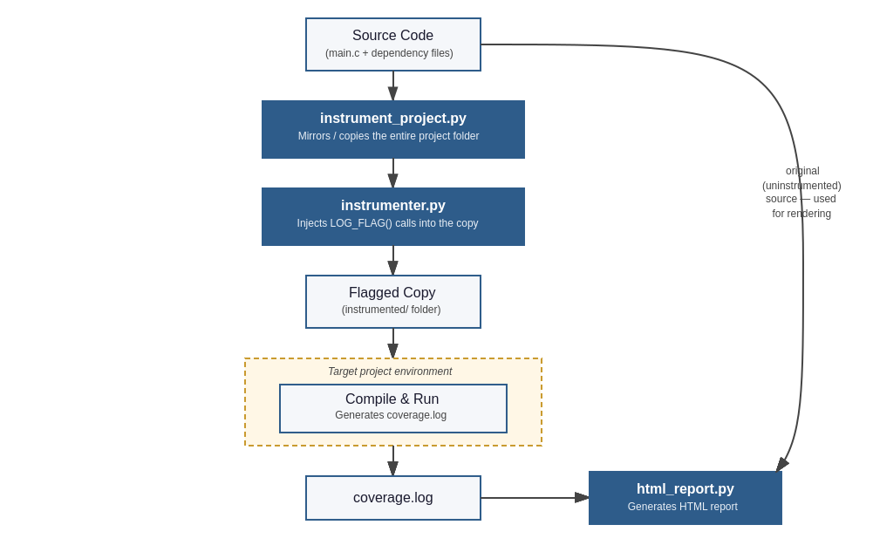
Figure 1: End-to-end pipeline — source code is copied and flagged, the flagged copy is built and run in its own project environment to produce coverage.log, which is then combined with the original source to generate the HTML report.

3.1 Component Overview
Component | Responsibility
instrumenter.py | Tokenises C/C++ source, identifies execution-block boundaries via recursive-descent parsing, and injects LOG_FLAG() calls at each boundary.
instrument_project.py | Mirrors an entire project folder (recursively), instruments every .c file found, and writes a runtime coverage.h header.
html_report.py | Reads coverage.log and the original source files, maps hit counts back onto source lines, and generates a colour-coded multi-page HTML report.
gui.py | Tkinter-based desktop interface providing folder browsing and one-click instrumentation / report generation.
Table 1: Core components and their responsibilities.

3.2 Processing Pipeline
The end-to-end workflow proceeds through five stages:
- Instrumentation — The user selects a project folder. The tool recursively mirrors the folder structure, then parses each .c file and injects a uniquely named LOG_FLAG("name") call at every detected execution-block boundary.
- Compilation — The instrumented files are compiled exactly as the original project would be (e.g. via gcc), since instrumentation is pure source-level C and introduces no external dependencies beyond the generated coverage.h header.
- Execution — The compiled binary runs normally. Each LOG_FLAG hit is buffered in memory and flushed to coverage.log in batches, minimising I/O overhead.
- Aggregation — coverage.log accumulates one line per execution-block hit, in the format <construct><index>_<filename>, e.g. if2_sensor.
- Reporting — The HTML report generator reconstructs, for each original source file, the exact line ranges every block covers, cross-references them against the hit counts in coverage.log, and renders the source with green (executed) or red (never executed) highlighting — with the most deeply nested block always taking visual precedence over its containing block.

3.3 Flag Naming Convention
Every execution block receives a flag name of the form <construct><index>_<filename>, where construct identifies the block type (func, if, else, while, for, do, switch, case) and index is a per-file, per-construct sequential counter. This scheme guarantees uniqueness across an entire multi-file project without requiring any central coordination — two files can each have their own if1_<filename>, and the filename suffix prevents collisions.

4. Implementation

4.1 Block-Boundary Detection
Embedded C/C++ code is typically organised around a relatively small set of functions, each implementing a distinct piece of behaviour — a sensor read, an actuator command, a state-machine step — with control logic (if/else ladders, loops, switch statements) nested inside. Because of this, block-boundary detection is built around the function as the outermost unit: the Analyser first locates each function definition, then recursively walks its body to locate every nested control-construct boundary inside it.
The Analyser class tokenises the source using a regular-expression-based lexer that recognises comments, string literals, character literals, preprocessor directives, braces, and control-flow keywords as distinct token types. A recursive-descent walk over this token stream identifies the start and end of every execution block. Function blocks are treated as the anchor for this walk: a function's flag block always begins at its opening brace and extends to its closing brace, regardless of how many return statements, branches, or loops are nested inside it. This means a function's overall coverage state is always correctly tied to its true start, with each nested construct (if, while, switch, etc.) layered on top as its own independently tracked block.
if context == "function":
if not has_return:
flag = self._next("func")
self.insert_flag_before_rbrace(close_pos, flag)
self._record(flag, open_pos, close_pos)
else:
# extend the return-flag block to include the closing }
open_line = char_to_line(self.source, open_pos)
for entry in reversed(self.block_map):
if entry["flag"].startswith("func") and \
entry["start_line"] == open_line:
entry["end_line"] = char_to_line(self.source, close_pos)
break
Listing 1: A function's recorded block always begins at its opening brace, anchoring coverage to the function's true entry point regardless of nested branches or return statements.

4.2 Same-Line Brace Normalisation
Source code submitted for instrumentation may have formatting inconsistencies — for example, braces written on the same line as their controlling statement rather than on their own line:
for (int i = 0; i < 4; i++) {control_actuator(i);}
Example: a same-line brace style that does not follow one-brace-per-line formatting.
Since flag insertion is line-based, formatting like this would otherwise cause a flag to be inserted next to the wrong line. To handle this safely, a normalisation function runs before tokenisation. It scans the source for every brace that shares a line with other code and pushes that brace onto its own line, so that the structure of the block is unambiguous before any flags are inserted. This guarantees that, regardless of the original formatting style, each LOG_FLAG call is correctly placed inside the block it belongs to.

4.3 Runtime Logging Macro
The LOG_FLAG macro is responsible for recording each block hit during program execution. To keep this lightweight even inside loops that run millions of times, hits are not written to disk individually. Instead, they are collected in a small in-memory buffer, and the buffer is flushed to coverage.log only once every N hits (1,000 by default) — turning thousands of individual writes into a single batched write, which significantly reduces time complexity for high-iteration code paths.
An atexit() handler is also registered, which flushes any hits still sitting in the buffer when the program terminates normally. This ensures that even the final, incomplete batch — the hits accumulated since the last 1,000-hit flush — is still written out. Combined with the periodic flush, this means coverage data is recorded progressively throughout execution rather than only at the very end, so meaningful coverage information is preserved even if the program is interrupted or exits unexpectedly partway through a run.
#define LOG_FLAG(name) do { \
if (!_cov_atexit_registered) { \
atexit(_cov_close); \
_cov_atexit_registered = 1; \
} \
snprintf(_cov_buffer[_cov_count], COV_LINE_MAXLEN, \
"%s\n", name); \
_cov_count++; \
if (_cov_count >= COV_BUFFER_HITS) { \
_cov_flush(); \
} \
} while(0)
Listing 2: LOG_FLAG buffers hits in memory and flushes every N hits; atexit() flushes any remaining buffered hits on normal termination.

4.4 Visual Coverage Resolution
The HTML report resolves, for every source line, the colour of the most specific (shortest-span) execution block containing it. This produces intuitive nested highlighting: a while loop that executed shows green across its entire body, except for any inner if branch that was never taken, which renders red — even though it sits inside an otherwise-executed outer block.
candidates.sort(key=lambda c: c[0]) # shortest span first
span, colour, hit_count, flag, is_first = candidates[0]
Listing 3: Most-specific-block-wins resolution for nested coverage highlighting.

5. Results
The tool was validated against a representative three-file embedded simulation comprising a main control loop (main.c) and two driver modules (sensor.c, actuator.c), covering if/else ladders, nested switch statements, while and for loops, and functions both with and without return statements.

5.1 Flag Injection Summary
File | Blocks Instrumented | Constructs Covered
main.c | 16 | while, if/else if/else, switch, nested switch
sensor.c | 7 | if, for, if/else if/else (nested in for)
actuator.c | 9 | switch, case exits, function bodies
Table 2: Flag injection results across the sample three-file project.

5.2 Performance Improvement
A stress test issuing five million LOG_FLAG hits from a single tight loop was used to measure the effect of batched buffering against the original per-hit file I/O approach.
Logging Strategy | Hits | Measured / Extrapolated Time
Per-hit fopen/fprintf/fclose | 5,000,000 | ≈ 20.4 seconds (extrapolated)
Batched in-memory buffer (1,000/flush) | 5,000,000 | 0.876 seconds (measured)
Table 3: Performance comparison between unbuffered and batched logging strategies, demonstrating a measured speedup of approximately 23× under controlled conditions, with substantially larger real-world gains observed at production scale (1.8M+ recorded hits).
All 5,000,000 recorded hits were verified present in the output log with the batched approach, confirming no data loss under normal program termination.

5.3 Coverage Report Output
The generated HTML report correctly distinguishes executed from non-executed branches at the line level. For example, in the sensor module's read_sensor() function, the function body (lines spanning the opening brace through the return statement) is shown fully green, while a nested if (fake_reading > 200) branch that was never triggered during the test run is correctly isolated and rendered red — despite being nested inside an otherwise fully green function body.
The report is organised as an index page listing every instrumented file alongside its overall coverage percentage, with each filename linking to a dedicated, full-page colour-coded view of that file's source — supporting projects with an arbitrary number of files without producing an unwieldy single-page document.

6. Conclusion
This project demonstrates that meaningful, branch-level code coverage analysis for embedded C/C++ projects can be achieved entirely through source-level static instrumentation, without dependency on compiler-specific coverage flags or complex toolchain integration. By combining a custom recursive-descent source analyser with a low-overhead batched runtime logging strategy, the tool remains practical even for code paths executing millions of times, while still producing an intuitive, visually navigable coverage report mapped directly onto the original source.
Key engineering lessons from this work include the necessity of normalising source formatting (same-line braces) before structural analysis, the importance of correctly anchoring function-level coverage to the function's true entry point rather than its return statement, and the dramatic performance impact of naive per-event file I/O in instrumentation contexts — addressed here through batched, buffered logging with a bounded data-loss window in the event of abnormal termination.

